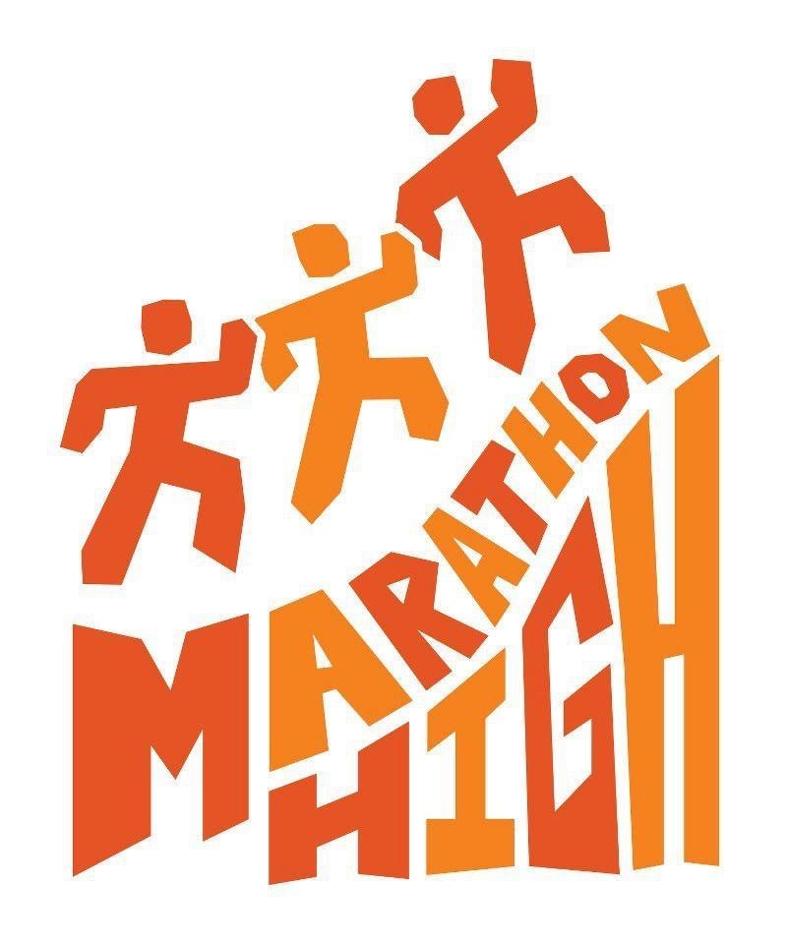

SEASON 12 Marathon High Scholarship Application

Marathon High is a nonprofit organization that encourages students to experience the benefits of goal-setting, character development, adult mentoring and improved health by completing the Donna 13.1 Half Marathon and staying in school.

Up to a total of $5,000 in scholarships will be awarded this spring to be distributed in $500 increments to a maximum of 10 students. These scholarships are made possible by generous contributions from our community. They are available for post-high school education in two- or four-year colleges, trade schools, or fine arts programs beginning in the summer 2023 or fall 2023 semester. Applicants will be evaluated based on their participation in Marathon High including their character, attitude, teamwork and attendance during the season. The essay, number of seasons in Marathon High, and demonstrated financial need will also be weighted heavily in our decision.

Qualifications:
- Graduating high school senior in the Class of 2023
- College ready
- Active Marathon High participant who completed at least the 2022-2023 Marathon High season and the 2023 Donna 13.1

Procedures to apply:
- Complete the attached application, including a recommendation from one Marathon High coach.
- Compose an essay about how Marathon High has affected your life.
- Application and essay must be typed.
- Attach a college acceptance letter or Letter of Intent, if available.
- Submit 5 complete copied sets of the application, including all of the above.
- Deadline: April 1, 2023. Entries received after the deadline will not be accepted.
- Winning recipients will be notified by April 17, 2023.

Submit applications to:
Marathon High, Attn: Sarah Olson
2409 Cimarrone Blvd
Saint Johns FL 32259

Deadline: April 1, 2023
MARATHON HIGH APPLICANT INFORMATION

Last Name: First Name:

Street Address:

City, State, Zip:

Date of Birth: School Currently Attending:

Parent/Guardian Email: Student Email:

Parent/Guardian Cell: Student Cell:

Name of Marathon High coaches:

Years participated in Marathon High:
_____2019-2020 _____2020-2021 _____2021-2022 _____ 2022-2023

Cumulative Weighted Grade Point Average:

Activities in addition to Marathon High (sports, clubs, job, volunteer, etc.):

College/School I Plan to Attend:

What I Plan to Study:

Statement of Financial Need:

Explain financial circumstances within the family which might make it difficult for you to reach your educational goals such as other brothers or sisters in college, unemployment etc. Also name any other scholarships or grants awarded or applied for.

Applicant Essay:

Describe how your Marathon High experience affected you. Did it help you overcome a personal challenge, provide a health benefit, change how you feel about yourself and life, motivate you to attend college, join the military, etc.? Explain the biggest impact that Marathon High had on you and how you felt changed by it. (You can type right into this document.) 600 words minimum.

CERTIFICATION

In submitting this application, I certify that the information is complete and accurate to the best of my knowledge. I understand that I may be required by the Scholarship Committee to provide documentation to corroborate the information in this application in order to receive scholarship payments. Falsification of information will result in termination of any scholarship granted. I also give Marathon High permission to use this essay, in whole or in part, for promotional purposes.

_______________________________________________________________________________
Applicant’s Signature Date

Marathon High Coach’s Statement:

Please describe this student’s character, attitude, commitment, attendance, and teamwork in Marathon High. We are specifically looking for your input on how this student was on your Marathon High team and why you think he/she would be a good choice to receive a scholarship.

_______________________________________________________________________________
Coach’s Signature Title Date

